Greg Seda

CS443 -- Assignment 3

Write the queries necessary to obtain the required information.  Make sure all columns you return have descriptive column headings.

1) Return the Minimum and Maximum sales for all offices.

SELECT MIN(sales) as Minimum_Sales, MAX(sales) as Maximum_Sales

FROM Offices;

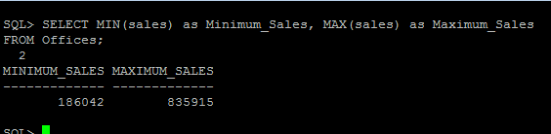

2) Determine how many orders were made in 1989.  Return the number of rows that meet this condition.

SELECT Count(*) AS OrderDate_1989

FROM Orders

Where Order_Date LIKE ‘%89’;

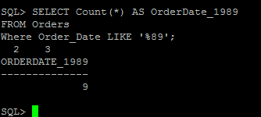

3) List the number of different titles in the sales reps table. Only list each title once and unknown titles should be ignored.

SELECT COUNT(DISTINCT TITLE) AS Different_Titles, Title

FROM SALESREPS

GROUP BY Title;

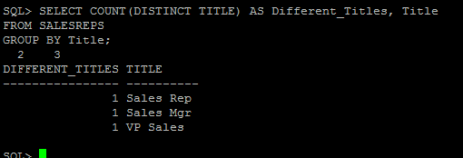

4) List the average quota for salesreps in office 21.

SELECT AVG(quota) as Average_Quota

FROM salesreps

Where rep_office = 21;

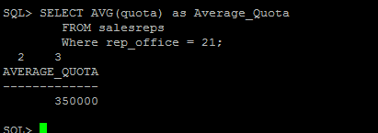  
  
5) List the average sale amount for all sale reps in each office.

SELECT salesreps.rep_office, AVG(salesreps.sales) AS Average_Sales_Amount

FROM Salesreps, Offices

WHERE Salesreps.rep_office = offices.office

GROUP BY salesreps.rep_office;

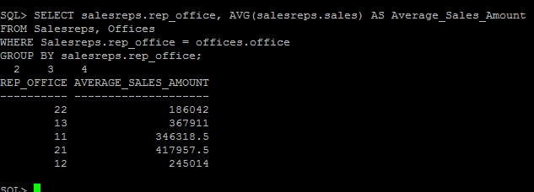

6) For each salesrep that has made an order, list the minimum, maximum and average order amount for all their orders.  Include only those orders made anytime from 1990-1999.  Omit from the list any salesrep that has only made 1 order in this time frame.  Sort the results by Empl_Num.

SELECT salesreps.empl_num, MIN(Orders.amount) AS Min_Order_Amount,    MAX(Orders.amount) AS Max_Order_Amount,

AVG(Orders.amount) AS AVG_Order_Amount

FROM Orders, Salesreps

WHERE (Salesreps.empl_num  = orders.rep)

AND (Orders.Order_Date BETWEEN '01-JAN-90' AND '31-DEC-99')

GROUP BY Empl_Num

HAVING COUNT(Order_Num) > 1

ORDER BY Empl_Num;

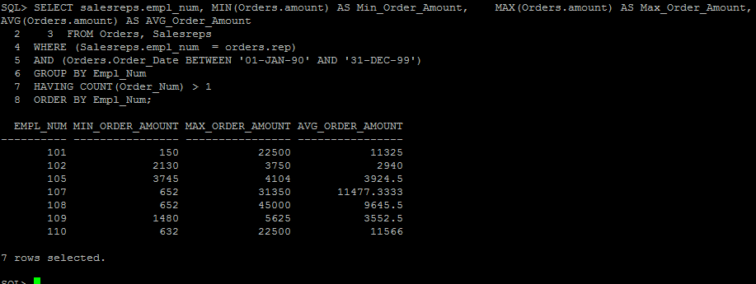

7) Use a sub-query to list the Customer number; Name and Credit Limit of any customers who have exceeded their credit limit (amount > credit limit) on any order.

SELECT DISTINCT Customers.cust_num, Customers.Company, Customers.Credit_Limit

FROM Customers

WHERE Customers.Credit_Limit <

ANY (SELECT Amount

FROM Orders

WHERE Orders.Cust = Customers.Cust_Num);

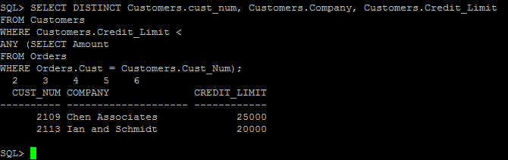  
  
  
8) Use a subquery and using the “all” keyword to find the customer number, Salesrep id, and CreditLimit of every customer whose CreditLimit is larger than the CreditLimit of all of the customers of sales rep number 109.

SELECT Customers.Cust_Num, Salesreps.empl_num, Customers.Credit_Limit

FROM Customers, Salesreps

WHERE Customers.Cust_Rep = Salesreps.empl_num

AND Customers.Credit_Limit > ALL

(

SELECT Customers.Credit_Limit

FROM Customers

WHERE Customers.Cust_Rep = 109

);

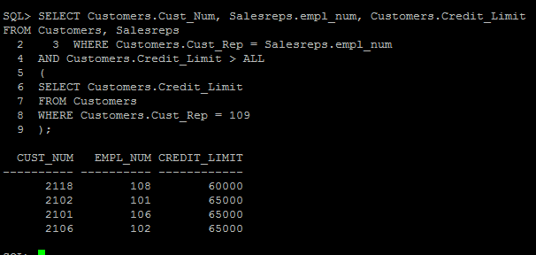

9) Do question 8, still using the subquery but do not use the “all” keyword.

SELECT Cust_Num, Cust_Rep, Credit_Limit

FROM Customers

WHERE NOT (Credit_Limit <= ANY

(SELECT S1.Credit_Limit

FROM Customers S1

WHERE S1.Cust_Rep = 109));

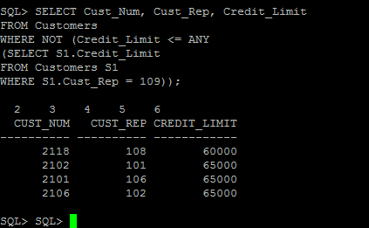

10)  Use sub query and “in” keyword to print the salesreps (ids) who have taken order for the companies ‘Zetacorp’ or ‘JCP Inc.’ . Duplicate rows is not allowed

SELECT Salesreps.Empl_Num

FROM Salesreps

WHERE Salesreps.empl_num IN

(

SELECT Rep

FROM Orders

WHERE Cust IN

(

SELECT Cust_Num

FROM Customers  
WHERE Company = ‘Zetacorp’ OR Company = ‘JCP Inc.’));  
  
  
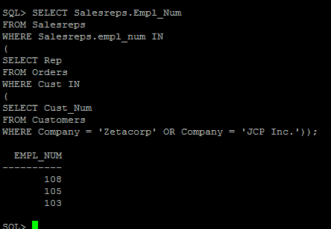  
  
  
11)  Use sub query to find the id and the name of every sales rep that represents at least one customer with a credit limit of greater than $5000.

SELECT DISTINCT Salesreps.empl_num, Salesreps.name

FROM Salesreps

WHERE Salesreps.empl_num IN

(

SELECT Customers.cust_rep

FROM Customers

WHERE Customers.Credit_Limit > 5000

);

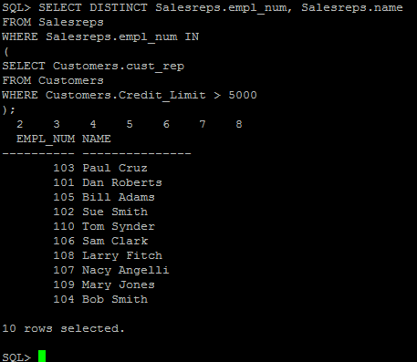

12)  Use sub query and keyword “exists” to list the id and the name of the salesreps in which some customers have orders some products in their hiredate.

SELECT Salesreps.Empl_Num, Salesreps.Name

FROM Salesreps

WHERE EXISTS

(

SELECT Orders.Rep

FROM Orders

WHERE(Salesreps.Hire_Date = Orders.Order_Date)

);

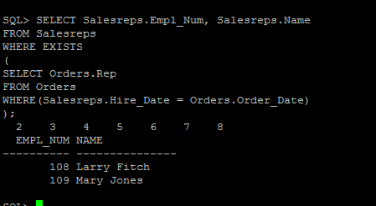

13)  List all the products (Mfr_ID and Product_ID) that have never been sold. Use the ‘Exists’ clause.

SELECT MFR_ID, Product_ID

FROM Products

WHERE NOT EXISTS

(

SELECT QTY

FROM Orders

WHERE MFR_ID = MFR AND Product = Product_ID

);

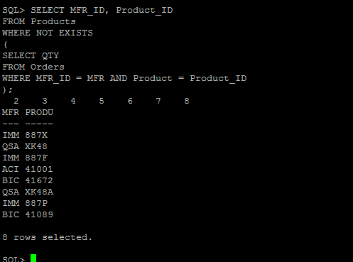

**Updates Questions:**

14)  Insert the following information into the OFFICES table:

**Office:  39  City: Miami Region: Southern   Manager: 106  Target: 1000000 Sales: 0**

insert into offices values(39,'Miami','Southern',106,1000000,0);

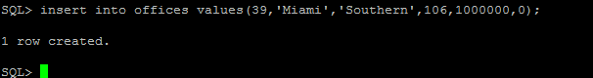

15)  Write an insert statement to add Your Name as Empl_Num 772.  Use the date the insert is run as the Hire date (sysdate). Sales are zero.  Other column remain NULL;

insert into salesreps (Empl_Num, Name, Hire_Date, Sales) values (772,'Greg Seda',sysdate,0);

SELECT * FROM Salesreps WHERE Empl_Num = 772;

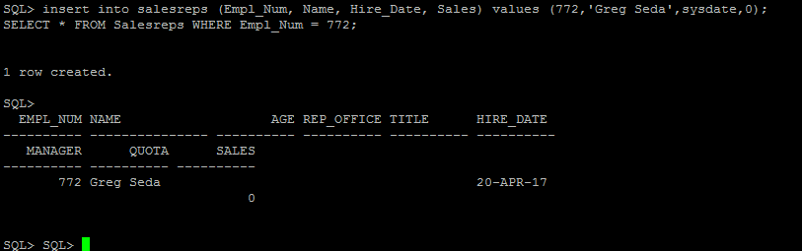  
  
  
  
16)  Write an insert statement to add 'Tom Sawyer' Empl_Num 814.  Use the date the insert is run as the Hire date (sysdate). Sales are zero.  Use implicit null values for columns that are not mentioned.

insert into salesreps values (814,'Tom Sawyer’',NULL,NULL,NULL,sysdate,NULL,NULL,0);

SELECT * FROM Salesreps WHERE Empl_Num = 814;

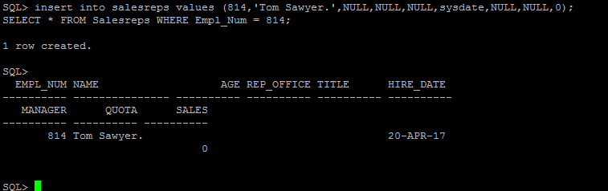

17)  Delete all orders for employees 108, 101, 102.

DELETE FROM Orders

WHERE Rep = 108 OR Rep = 101 OR Rep = 102;

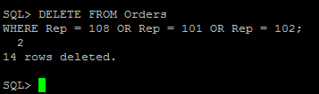

18)  Delete all sales reps that have no orders and were hired before Jan 1 1987.

DELETE FROM Salesreps

WHERE (TO_DATE(Salesreps.Hire_Date, ‘DD-MON-YY’) < TO_DATE(‘01-Jan-87’, ‘DD-MON-YY’))

AND NOT EXISTS

(

SELECT REP

FROM Orders

WHERE( Salesreps.empl_num = orders.rep)

);

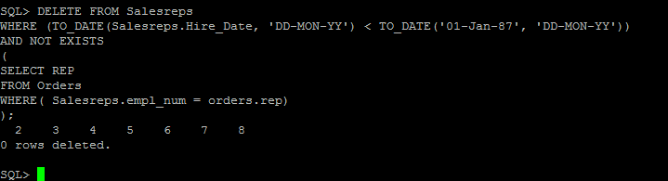

19)  Update your employee record with the following:

**Age: 37 Rep_Office:39    Title: Senior VP     Manager: NULL              Quota: 100000**

UPDATE Salesreps

SET age = 37, Rep_office = 39, title = ‘Senior VP’, manager = NULL, Quota = 100000

WHERE Empl_Num = 772;

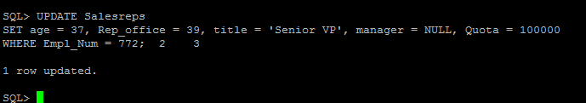

20)  Increase customers credit limit by 20% for all customers that have 2 or more orders in which each order is more than 25,000.

UPDATE Customers

SET Credit_Limit = (Credit_Limit * 1.2)

WHERE Cust_Rep = ANY

(SELECT CUST

FROM Orders

WHERE (Amount > 25000)

GROUP BY Cust

HAVING COUNT(Cust) >= 2);

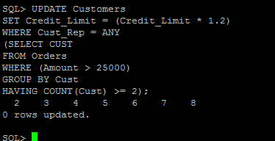  
  
  
  
21)  Increase the credit limit of any customer who has any order that exceeds their credit limit.  The new credit limit should be set to their maximum order amount plus $1,000.  This must be done in 1 SQL statement.

UPDATE Customers

SET Customers.Credit_Limit =

(

SELECT Max(Orders.Amount)

FROM Orders, Customers

WHERE Orders.Cust = Customers.Cust_Num) + 1000

WHERE Customers.Credit_Limit < ANY

(

SELECT Orders.Amount

FROM Orders

WHERE Orders.Cust = Customers.Cust_Num

);

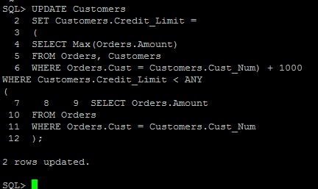

**Views and Security Questions**

22)  Create a view to show the Sales rep Name, and city that the Sales rep works in.

DROP VIEW Question22;

CREATE VIEW Question22 AS

SELECT Salesreps.Name, Offices.City

FROM Salesreps, Offices

WHERE (Salesreps.Rep_Office = Offices.Office);

SELECT * FROM Question22;

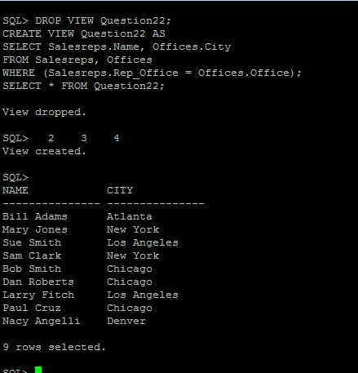

23)  Grant select access of the view created in question 22 to your Database instructors: Ahmad R. Hadaegh (with user id ahadaegh).

GRANT SELECT

ON Question22

TO ahadaegh;

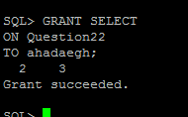

24)  Create a view to show the customer name, product, description, quantity ordered and value of parts ordered.  The column heading for the customers name should be ‘CustName’ and the column heading for value of parts ordered should be ‘Value’.

DROP VIEW Question24;

CREATE VIEW Question24 AS

SELECT Customers.Company AS CustName, Products.Product_ID, Products.description, Orders.QTY, Products.Price AS Value

FROM Customers, Orders, Products

WHERE Products.Product_ID = Orders.Product

AND Orders.Cust = Customers.Cust_Num

AND Products.MFR_ID = Orders.MFR;

SELECT * FROM Question24;

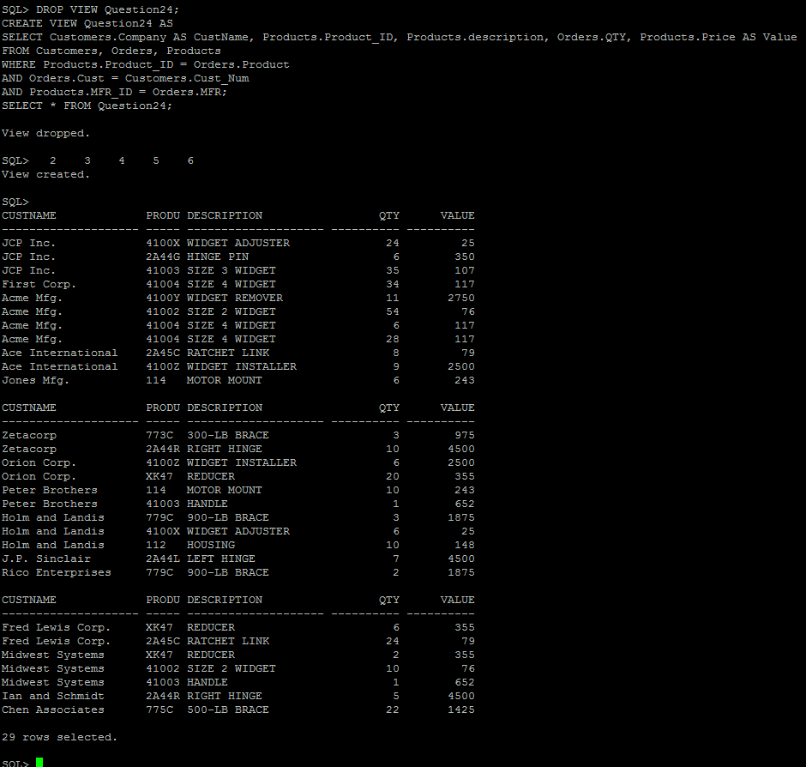

25)  Grant select access of the view created in question 24 to public

GRANT SELECT

ON Question24

TO PUBLIC;

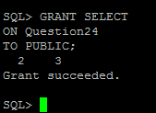

26)  Revoke access on view created in question 24 from Public.

REVOKE SELECT

ON Question24

FROM PUBLIC;

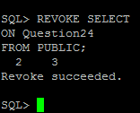

27)  Using the view created in question 24 above, list all information for product ‘L14’.

SELECT *

FROM Question24

WHERE Product_ID = ‘L14’;

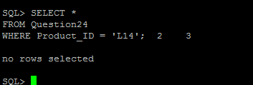

28)  Create a view called TheManagers to list the name of all sales reps that manage some office.  Along with the managers name, list the office number and city for each office.

DROP VIEW TheManagers;

CREATE VIEW TheManagers AS

SELECT Salesreps.Name, Offices.Office, Offices.City

FROM Salesreps, Offices

WHERE Empl_Num = MGR;

SELECT * FROM TheManagers;

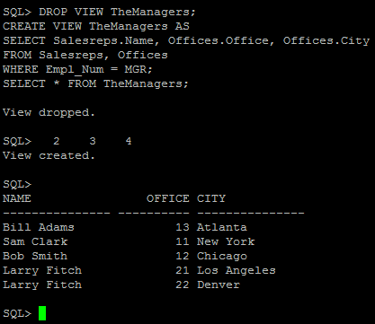

29)  Grant all privileges on the view created in question 28 to your instructor.

GRANT ALL PRIVILEGES

ON TheManagers

TO ahadaegh;

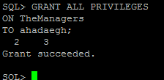

30)  Grant Select, Insert and Update on the Offices table to userids ‘jschmidt’ and ‘kmart’.

GRANT SELECT, INSERT, UPDATE

ON Offices

TO jschmidt, kmart;

